C-WorKS: COVID-19 consequences Want it? or Know it? Share it!

C-WorKS has been set up to support the collation and sharing of knowledge and intelligence across the system about the impacts of COVID-19 (and the response to this) on non-COVID morbidity and mortality – to cover key areas of concern but also include any positive impacts

Want it?

Questions around the impact of COVID-19 on non-COVID health issues? C-WorKS provides a forum to make links with people, groups and organisations who may have the intelligence you need, or those who are able to assist in answering your questions.

Know it?
Have knowledge and intelligence resources and analysis relating to the impact of COVID-19 on non-COVID health issues? C-WorKS provides a forum for you tell others about this.

Share it!

Providing contact details within C-WorKS will help to link people, groups and organisations together to share common areas of working, intelligence needs, resources and insights.

Where to start? To get involved with C-WorKS, you first need to register on KHub and join the PHINE KHub group (Guide below).
Once a member, you can find out more about the background to this work here as well as exploring the Wiki pages on the following topics: Excess mortality, Health inequalities, Health-seeking behaviour, Health service disruption, Mental health and well-being, Wider health and care services, Staff and organisational issues and Wider determinants of health.
If you Want to know more about a topic, each page has a comment function for you to add a question, start a discussion or suggest potential projects. or if you Know it, you can Share it by adding details to the table on each page (example below).
The aim is for members to add their own resources and contact others who working on the same issue. However, if you would like us to add resources on your behalf please complete the table below and return to Louise Gray louise.gray@phe.gov.uk. Louise can also help if you need support navigating the C-WorKS pages and adding content.
What’s next? We plan to adapt C-WorKS overtime to make sure it is best serving the needs and wants of its users.
We hope you will join in and contribute to C-WorKS to support the collation and sharing of knowledge and intelligence across the system in our region, and ultimately contribute to making sure the work we all do is fully informed to have the maximum effect on reducing non-COVID morbidity and mortality brought on by COVID-19 and the response to this.
If you would like us to add resources to C-WorKS, please add the details to the table below – a row for each resource – and return to Louise Gray louise.gray@phe.gov.uk
Short title | Main description  Give brief overview of the knowledge and/or intelligence resource including the organisation and/or individual who produced it. Try to include time-period and date produced and embed hyperlinks to more details elsewhere.  If you have resources ready to share but nowhere to ‘host’ them we can add them to the PHINE KHub Library when we establish a new folder structure for this project. Please indicate this preference in the description. | Available geographies  (if relevant) | Contact details  This can be a generic or individuals email and/or contact number where network members can find out more and/or gain access to the resources | Topic  This is an extra column for you to indicate which topic page the resource should be added to:  - Excess mortality  - Health inequalities  - Health-seeking behaviour  - Health service disruption  - Mental health and well-being  - Wider health and care services  - Staff and organisational issues  - Wider determinants of health  - Blogs, newsletters and bulletins
EXAMPLE  Deaths involving COVID-19 by local area and deprivation | Office for National Statistics produces provisional counts of the number of deaths and age-standardised mortality rates involving the coronavirus (COVID-19) in England and Wales available here. Figures are provided by age, sex, geographies down to local authority level and deprivation indices. | Down to local authority | Sarah Caul  Health.Data@ons.gov.uk  +44 (0)1633 456490 | 1.

How to join C-WorKS

Step one:

In order to access the C Works Knowledge Hub you will first need to register on Khub if you haven’t already. Please click here to set up your account.

Step two:

Once your account has been created please navigate to the PHINE Network North East Group. This is a restricted group for those working within a public health remit, so you need to request access to join. Request access by clicking the ‘request to join’ button on the left-hand side of the front page.

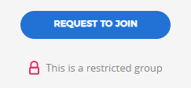

Step three:

Once access to PHINE Network North East has been granted please access the C-WorKS Knowledge hub via the landing page here or by clicking on the ‘wiki’ tab found across the top of the front page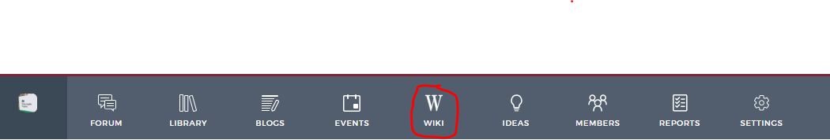

Further information about Khub is contained within the embedded ‘Khub overview’ document at the top of this page.

